|  |
| --- |
| MAJOR PROJECT REPORT |

KNEE OSTEOARTHRITIS PREDICTION AND ITS SEVERITY

SUBMITTED IN PARTIAL FULFILMENT OF THE REQUIREMENTS FOR THE AWARD OF DEGREE OF

**BACHELOR OF TECHNOLOGY**

**IN**

**INFORMATION TECHNOLOGY**

**Submitted By:**

|  |  |  |  |
| --- | --- | --- | --- |
| Name: | Akhil Katyal | Anmol Sehdev | Ishita Seth |
| University Roll No. | 1903815 | 1903819 | 1903835 |

**Under the supervision of**

Mr. Jaswinder Singh Dhillon

Assistant Professor(IT)

**DEPARTMENT OF INFORMATION TECHNOLOGY**

# DAV INSTITUTE OF ENGINEERING & TECHNOLOGY Jalandhar – 144008

**CERTIFICATE**

We hereby declare that the work which is being presented in the report entitled KNEE OSTEOARTHRITIS PREDICTION AND ITS SEVERITY Here by our team in partial fulfillment of requirements of the award of degree of Bachelor of Technology submitted in the Department of Information Technology DAVIET, Jalandhar is an authentic record of our own work under the supervision of Mr. Jaswinder Singh Dhillon, Assistant Professor-IT. The matter presented in this report has not been submitted by us in any other University/Institute for the award of Degree/Diploma.

Akhil Katyal [1903815] Anmol Sehdev [1903819]

Ishita Seth [1903835]

This is to certify that the above information made by the candidates is correct to the best of my knowledge.

Mr. Jaswinder Singh Dhillon

The Viva-Voce Examination is held at Department of Information Technology , DAVIET, Jalandhar on 27 January 2023.

Signature of External Examiner

Signature of HOD (IT)

Dr. Dinesh Kumar

**ABSTRACT**

This project “ KNEE OSTEOARTHRITIS SEVERITY AND PREDICTION ” is solution and an easier way for people who are suffering from Knee Osteoarthritis . The patients are now able to predict the severity of the problem by uploading the image of the knee. This project is a computer based system and it manages the records of patients and helps them provide necessary details regarding the problem.

Place: Jalandhar

Date: 27 January 2023

LIST OF FIGURES

LIST OF TABLES

**CONTENTS**

CERTIFICATE i

ABSTRACT ii

LIST OF FIGURES iii

LIST OF TABLES iv

CONTENTS v

1 INTRODUCTION

* 1. Introduction to Project………………………………………1
  2. Project Objective(s)………………………………………....1
  3. Features of the System………………………...…………….1

1. BACKGROUND STUDY
   1. Existing System……………………………………………..2
   2. Problems in Existing System………………………………..2
   3. Proposed System…………………………………………….2
2. SYSTEM ANALYSIS AND DESIGN
   1. Feasibilty Study……………………………………………..3
   2. SDLC Model used…………………………………………..3
   3. Software Requirement Specifications……………………….3
   4. Design Approach……………………………………………3
   5. System Design………………………………………………3
   6. Database Design…………………………………………….3
3. IMPLEMENTATION, TESTING AND MAINTENANCE
   1. Introduction to Languages, IDEs, Tools Used……………..4
   2. Testing Process……………………………………………4
   3. Testing Plan……………………………………………….4
4. RESULTS AND DISCUSSIONS
   1. Introduction…………………………………………………5
5. CONCLUSIONS AND FUTURE SCOPE
   1. Conclusions…………………………………………………6
   2. Future Scope………………………………………………..6

**CHAPTER 1**

INTRODUCTION

* 1. INTRODUCTION TO PROJECT:

Knee osteoarthritis (OA) is a very general joint disease that disturb many people especially people over 60. The severity of pain caused by knee OA is the most important portent to disable. Until now, the bad impact of osteoarthritis on health care and public health systems is still increasing.

FIGURE 1,1

Knee osteoarthritis model is build to detect the edge of the knee based on the X-ray image and predict the severity of OA. system first preprocessed to detect the contours of the knee and to remove noise. Then region of interest is extracted, and segmentation is carried out. In the third step, features are extracted using Deep Convolutional Neural Network (DCNN) hybridized as Convolutional Neural Network (CNN), Histogram of Oriented Gradient (HOG), and DCNN with Local Binary Patterns (LBP). Features are extracted as texture, shape, scaling, rotation, and translation. These extracted features are passed to multiclass classifier Support Vector Machine (SVM), K nearest neighbors (KNN), and Random Forest to classify the images into four grades according to the KL grading system. We use these algorithm to predict the severity of OA in knee X-ray images. The data is coming from the OsteoArthritis Initiative (OAI).

SCOPE:

This model holds significant promise in development of osteoarthritis clinical decision aid. For the Improvement of the early detection and management of osteoarthritis that will hypothetically reduce its censorious death rate, more development can we made on CNN models. Several different knowledge based models can be trained on a larger dataset with effective hyperparameter tuning and the model with optimal accuracy can be used for prediction.

CNN model can be trained on large dataset in order to increase the accuracy of the model and also to embrace new possibility & also show excellent performance with clinical experts in early detection of OA.

The proposed fully automated segmentation method provided good segmentation performance with segmentation accuracy superior to most of state-of-the-art methods in the publicly available knee image data set. The method also demonstrated versatile segmentation performance on both morphological and quantitative musculoskeletal MR images with different tissue contrasts and spatial resolutions.

1.2 PROJECT OBJECTIVE(S):

To evaluate the contributions of radiographic knee osteoarthritis (KOA) and knee pain severity

* To collect &analyze relevant datasets :
* mild dataset
* doubtful dataset
* normal dataset
* severe dataset
* moderate dataset

and use them to predict the signs of KOA.

* To develop a system that can reduce time -consumption & to reduce the uncertainties due to human error.
* To improve the accuracy of diagnosing the severity of KOA using CNN model
  1. FEATURES OF THE PROJECT:
* This system helps with instantly detecting signs of Osteoarthritis in knees.
* This system can provide the best prediction of the severity of the problem.
* Easy to use.
* To predict the risk of KOA at early stage.

**CHAPTER 2**

BACKGROUND STUDY

2.1 EXISTING SYSTEM:

It was a system that includes fuzzy c means algorithm for image segmentation. The fuzzy c means algorithm has been used for thermal image segmentation. The fuzzy c means algorithm is a technique for image segmentation and pattern recognition. Fuzzy c means algorithm is a combination of fuzzy algorithm and clustering. In this segmentation method the region of interest was segmented based on the clusters present in the object.

2.2 PROBLEMS IN EXISTING SYSTEM:

This system is complex and unable to recover from database corruption . This model required much more computational time because of the fuzzy measures calculations involved in the algorithms. This model is not good for noisy images.

2.3 PROPOSED SYSTEM:

The first step of the proposed system is preprocessing to detect the contours of the knee and to remove noise. Then region of interest is extracted, and segmentation is carried out. In the third step, features are extracted using Deep Convolutional Neural Network (DCNN) hybridized as Convolutional Neural Network (CNN), Histogram of Oriented Gradient (HOG), and DCNN with Local Binary Patterns (LBP). Features are extracted as texture, shape, scaling, rotation, and translation. These extracted features are passed to multiclass classifier Support Vector Machine (SVM), K nearest neighbors (KNN), and Random Forest to classify the images into four grades according to the KL grading system.

**CHAPTER 3**

SYSTEM ANALYSIS AND DESIGN

**3.1 FEASIBILTY STUDY:**

A feasibility study is an assessment of the practicality of a proposed plan or project. A feasibility study analyzes the viability of a project to determine whether the project or venture is likely to succeed. The study is also designed to identify potential issues and problems that could arise while pursuing the project.

Thus, since the feasibility study may lead to the commitment of large resources, it becomes necessary that it should be conducted competently and that no fundamental errors of judgement are made.

The acronym TELOS refers to the five areas of the feasibility- Technical, Economic, Legal, Operational and Scheduling.

**Technical Feasibilty:**

This is concerned with specifying equipments and software and hardware that will successfully satisfy the user needs. The technical needs of the system may vary considerably, but might include:

The facility to produce output in a given time.

Response time under certain conditions.

Ability to process a certain volume of transaction at a particular speed.

Facility to communicate data to distant locations.

Example :

We used VS CODE. The designing of front end of any project is very important so we select VS CODE as front end due to following reasons:

* Easy implementation of code
* Well defined interface
* Easy debugging

**Economic Feasibilty:**

A feasibility study may also include an economic analysis of the project. The purpose of economic analysis is to determine whether there is an economic case for the investment decision. This assessment goes beyond the items typically included in a financial analysis.

**Legal Feasibilty:**

A legal feasibility assessment is the process of checking an intended restructuring / steps plan for potential issues from a legal perspective, and preparing a plan to be implemented during the implementation phase of the restructuring, such that the intended restructuring entails a consolidated and integrated tax and legal assessment.

**Operational Feasibilty:**

Operational feasibility is the measure of how well a proposed system solves the problems, and takes advantage of the opportunities identified during scope definition and how it satisfies the requirements identified in the requirements analysis phase of system development.

It mainly related to human organisational and political aspects. The points to be considered are:

* What changes will be brought with the system?
* What organization structures are disturbed?

**Schedule Feasibilty:**

In scheduling feasibility, an organization estimates how much time the project will take to complete. When these areas have all been examined, the feasibility analysis helps identify any constraints the proposed project may face, including: Internal Project Constraints: Technical, Technology, Budget, Resource, etc.

**Market Research Studies:**

This is one of the most important sections of the feasibility study as it examines the marketeabilty of the product or services and convinces readers that there is a potential market for the product or services. If a significant market for the product or services cannot be established, then there is no project.

Typically, market studies will assess the potential sales of the product, absorption and market capture rates and project timings.

The feasibility study outputs the feasibility study report, a report detailing the evaluation criteria, the study findings and the recommendations.

**3.2 SDLC MODEL USED:**

We have used the prototyping model in the making of our project due to its several advantages:

The Prototyping Model is a system development method(SDM) in which a prototype (an early approximation of the final system or product) is built, tested, and then reworked as necessary until an acceptable prototype is finally achieved from which the complete system or product can now be developed. This model works best in scenarios where not all of the project requirements are known in detail ahead of time. It is an iterative, trial-and-error process that takes place between the developers and the users. There are several steps in the Prototyping Model:

The new system requirements are defined in as much detail as possible. This usually involves interviewing a number of users representing all the departments or aspects of the existing system.

A preliminary design is created for the new system.

A first prototype of the new system is constructed from the preliminary design. This is usually a scaled-down system, and represents an approximation of the characteristics of the final product.

The users thoroughly evaluate the first prototype, noting its strengths and weaknesses, what needs to be added, and what should to be removed. The developer collects and analyzes the remarks from the users.

The first prototype is modified, based on the comments supplied by the users, and a second prototype of the new system is constructed.

The second prototype is evaluated in the same manner as was the first prototype.

The preceding steps are iterated as many times as necessary until the users are satisfied that the prototype represents the final product desiredthe final system is constructed, based on the final prototype.

The final system is thoroughly evaluated and tested. Routine maintenance is carried out on a continuing basis to prevent large-scale failures and to minimize downtime.

**3.3 SOFTWARE REQUIREMENT SPECIFICATION:**

External Interfaces :

This contains a detailed description of all inputs into and outputs from the software system:

• It is an Integrated Web Portal to provide Information about knee xray details

• Purpose of this system is to provide relevant information of the condition of how severe the arthritis is.

• Information about previous databases from all hospitals.

USER Interface: the user interface for the software shall be compatible with any browser such as Internet Explorer, or Mozilla by which the user can access to the system.

Hardware Interface: user will only require a good internet connection. Since the application must run over the internet, all the hardware shall require to connect internet will be the hardware interface for the system

Functional Requirements:

REGISTRATION

If a user wants to use the portal, then the user must register him/herself first for further usage, an unregistered user cannot use the portal.

LOGIN

The user logs in to the portal by entering the valid user id and password otherwise a pop-up message with an error will be displayed.

BROWSING IMAGE

After the step logging in the user needs to browse the image of the x-ray from the documents.

UPLOADING IMAGE

Once the image browsing is done, the user has to upload the browsed image on the portal for further results.

RESULTS

After the image uploading, the user has to wait for the result of the diagnosis of knee OA.

Performance Requirements :

The product shall be based on the web and has to be run from a web server. The product shall take an initial load time depending on the internet connection strength which also depends on the media from which the product is run.

The process of a Convolutional Neural Network (CNN) performs four major steps:

Step - 1: Convolution

The objective of the operator is the extraction of input image features.

Step – 2: Pooling

This step is used to reduce the dimensionality of individual feature maps and

sustain the crucial information.

Step – 3: Flattening

Step – 4: Fully Connected Layer

The fully connected layer indicates that every neuron in the next layer is connected to every individual neuron in the previous layer.

The system must aim to use the minimum hard disk space yet to keep the quality of the available facility as high as possible.

Logical Database Requirements :

All data will be saved in the database: user accounts and profiles, AISHE data, etc. (except files that are stored on the disk). The database allows concurrent access and will be kept consistent at all times, requiring a good database design.

The communication between the portal software and the database will be in SQL.

MinimumSystem Requirements:

Software Requirements:

* Python
* Flask Framework
* Visual Studio Code
* MySQL Database

Hardware Requirements:

* Processor – Core i3 or above
* Windows 7 or higher
* Hard Disk – 160 GB or higher and Memory – 1GB RAM or higher

**CHAPTER 5**

RESULT AND DISCUSSIONS

**5.1 USER INTERFACE REPRESENTATION**

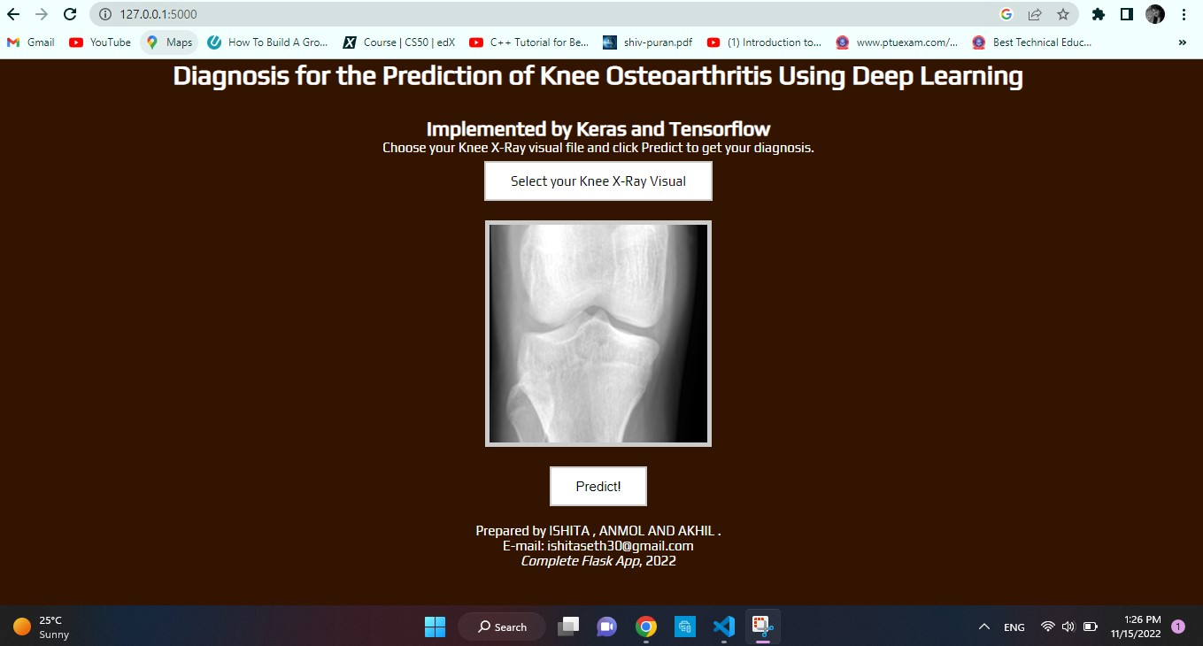

**5.2 Parameters used for evaluation**

**5.3 Comparative Analysis**

**5.3 Project screen shots with explanation**

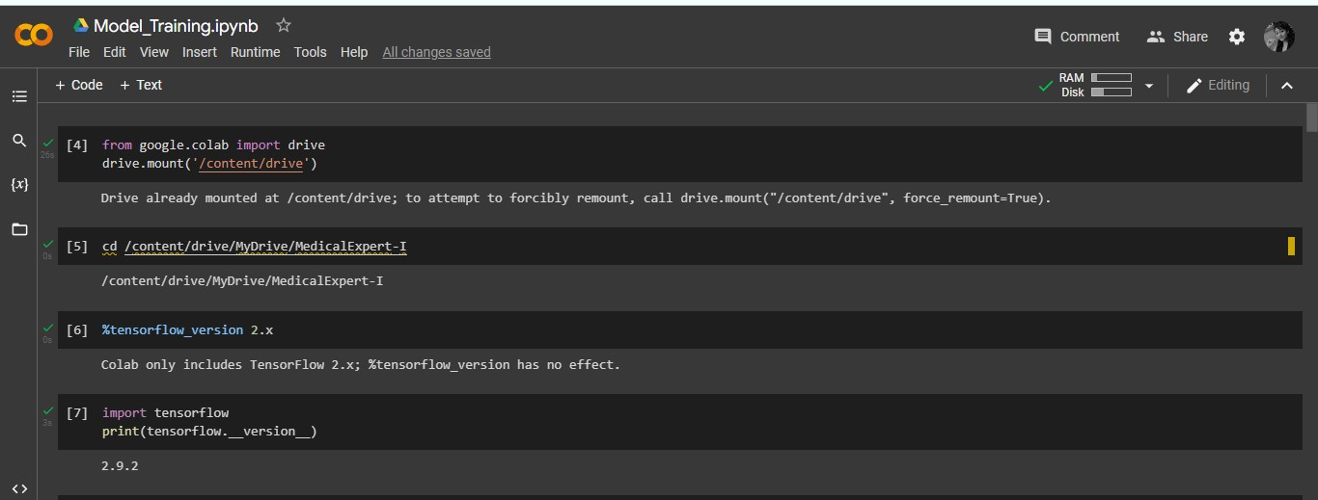

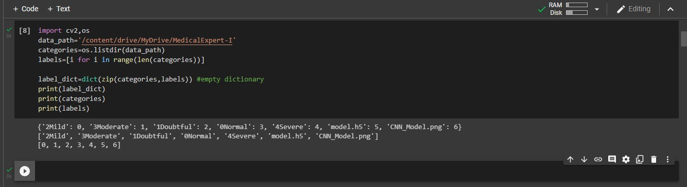

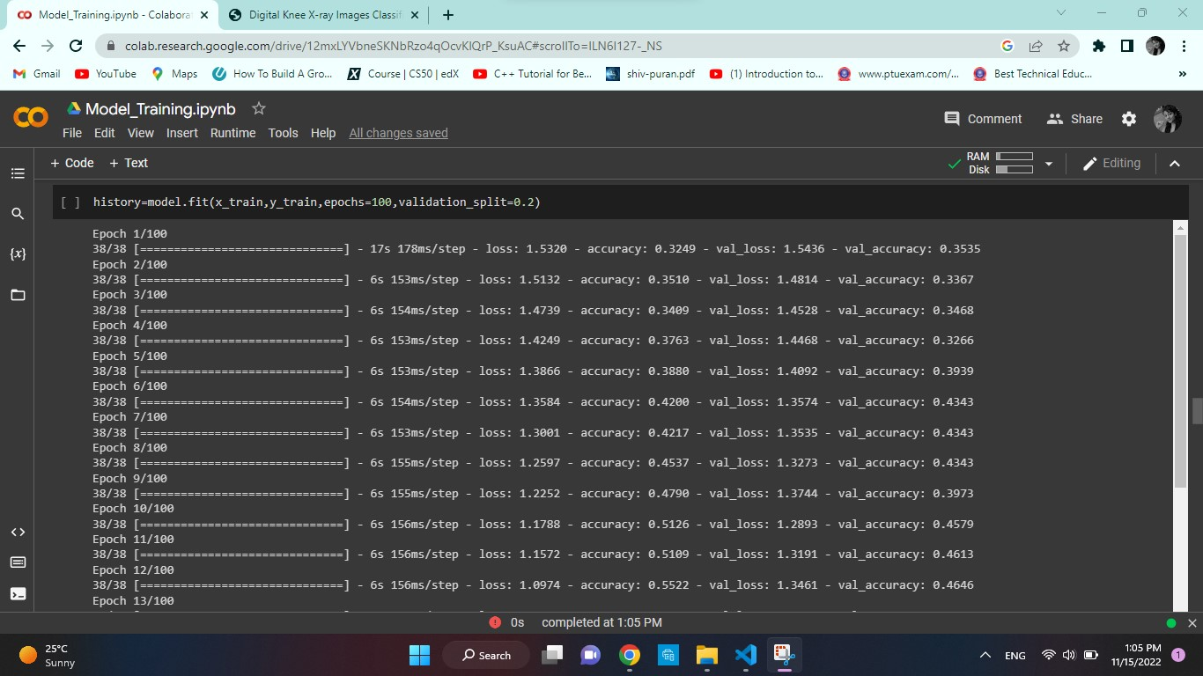

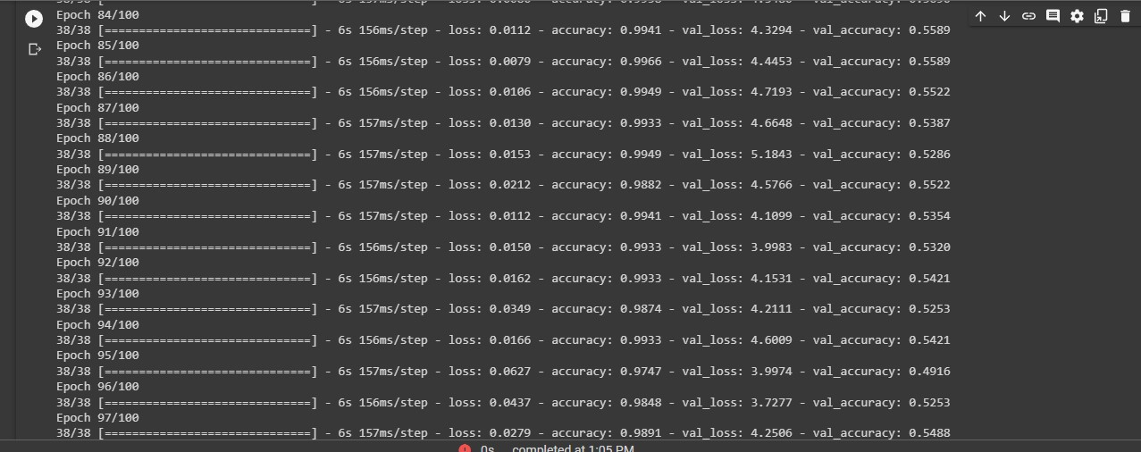



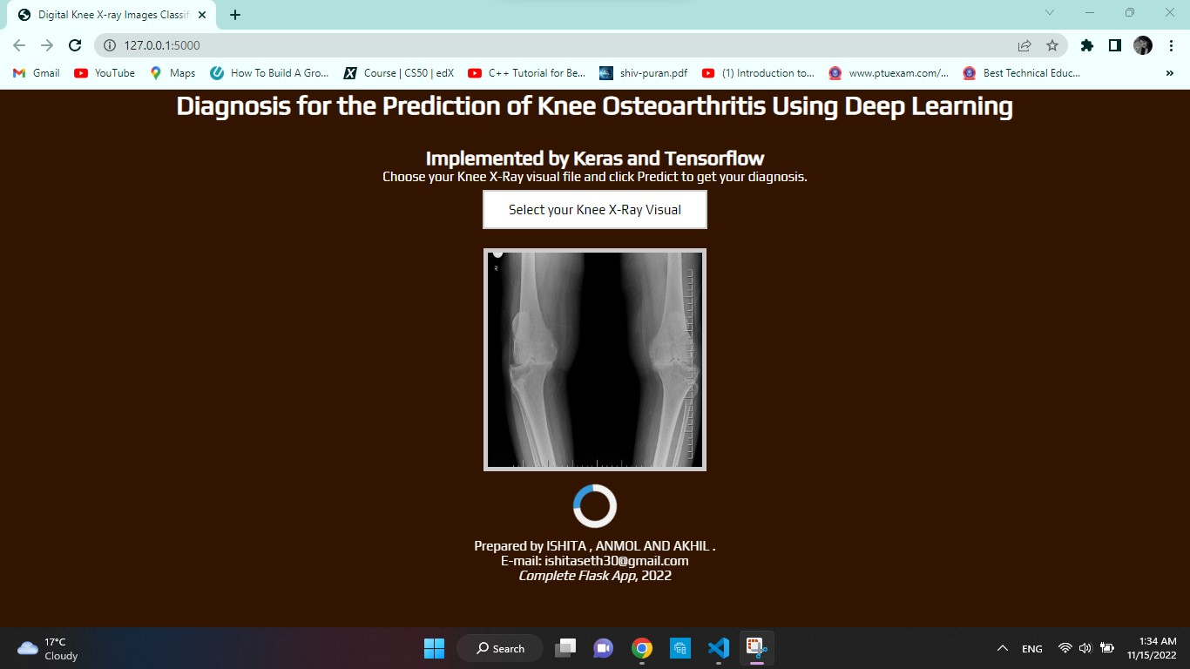

**CHAPTER 6**

**CONCLUSION AND FUTURE SCOPE**

**6.1 CONCLUSIONS:**

By using our research we can create and incorporate appropriate programs and commodities to encourage people to find there problem as early as possible.  
The main objective of this project was to build a program that help patient to know about how severe his / her knee condition is The system developed is able to meet all the basic requirements. The management of the records will be also benefited by the proposed system, as it will automate the whole procedure, which will help patient to find there problem as early as possible . The security of the system is also one of the prime concerns.  
There is always a room for improvement in any software, however efficient the system may be. The important thing is that the system should be flexible enough for future modifications. The system has been factored into different modules to make system adapt to the further changes. Every effort has been made to cover all user requirements and make it user friendly.

**Goal achieved**: The System is able provide the interface to the owner so that he can replicate his desired data..  
**User friendliness**: Though the most part of the system is supposed to act in the background, efforts have been made to make the foreground interaction with user(owner) as smooth as possible. Also the integration of the existing system with the project has been kept in mind throughout the development phase.

**6.2 FUTURE SCOPE:**

The Future Scope of this "KNEE OESTEOARTHRITIS PRPJECT" is quite flexible for various other platforms. Directly getting the data for the registered customers. This is quite an easy an accessible approach. This desktop application is more efficient way of getting result of patient by sitting at home .  
This initiative of creating awareness about this makes the healthy living of everyone .

This type of application can be further used but organised or built at different software, which can remove a slight dependency on manual work.  
Proper coupling technique.  
As all the modules are interlinked with each other so that we can go back or move to some other page directly.  
There is no Payment . IT is free of cost. All and All this application will truly enhance the automatization and reduce the manual work to extreme extent.